Lab4 – Apply different ML models

I conducted an extensive analysis of different Machine Learning models using quantitative metrics to assess their accuracy on a dataset. The dataset was well-preprocessed, with a strong correlation between the target column and the features, which led to low loss function values for each model. Additionally, I used Genetic Algorithm to select the best 30 features for these models, further enhancing their performance.

Initially, I applied Regression models to predict numerical values, and the results indicated that these models achieved high accuracy, as evidenced by their low loss function values.

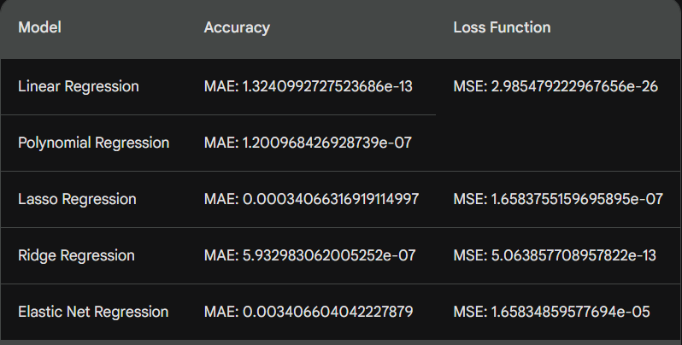

Subsequently, I transformed the target column into categorical data, enabling the application of classification models. These classification models were assessed for their accuracy, and the results were recorded.

Additionally, I extended my analysis by applying more classification models and visualized their performance using ROC curves, which can be found in the images folder.

Overall, this thorough evaluation allowed me to gain valuable insights into the suitability of different models for the dataset and to select the most appropriate ones for both regression and classification tasks.

Top of Form